**DOMAIN NAME SYSTEM (DNS)**

***Do you want to know what DNS means and how it works?***

**Introduction:**

When you type `www.google.com` into your browser, the website pops up almost instantly; that’s thanks to the Domain Name System (DNS). Think of DNS as the internet’s address book. It converts simple domain names into the numerical IP addresses computers use to find websites. This process happens quickly and seamlessly, letting you easily visit the sites and use online services.

***What is DNS?***

→ DNS stands for ***Domain Name System.*** While humans prefer remembering easy-to-type names like `www.google.com`, computers use numerical IP addresses to locate websites and services.  
→ DNS translates these user-friendly domain names into IP addresses that computers understand, allowing you to access websites without memorizing complex numerical strings.

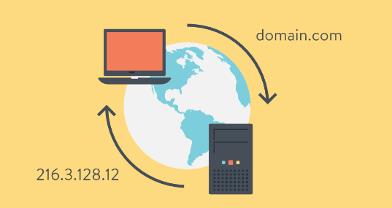

**Why DNS?**

1. ***User Convenience***: DNS allows users to access websites using domain names instead of complex IP addresses.
2. ***Load Balancing***: DNS can distribute traffic across multiple servers, enhancing performance and reliability.
3. ***Email Routing***: MX records help direct emails to the correct mail servers, ensuring reliable communication.
4. ***Security***: DNS includes features like DNSSEC (DNS Security Extensions) to protect against certain types of attacks.

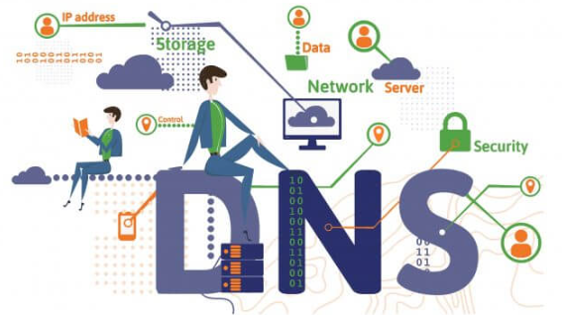

**What are DNS records?**

DNS involves several types of records, each serving a different purpose:

1. ***A record***maps a domain name to an IPv4 address.  
   ***For example***, google.com might point to `192.0.2.1`.
2. ***AAAA Record***: Maps a domain name to an IPv6 address.  
   ***For example,*** google.com might point to `2001:0db8:85a3:0000:0000:8a2e:0370:7334`.
3. ***CNAME Record***: Redirects one domain to another.  
   ***For example***, `www.google.com` might point to `example.com`.
4. ***MX Record***: Specifies mail servers for the domain.  
   ***For example***, `example.com` might have an MX record pointing to `mail.example.com`.
5. ***TXT Record***: Stores text data, often used for domain verification or email security.  
   ***For example***, it might contain SPF (Sender Policy Framework) records to prevent email spoofing.

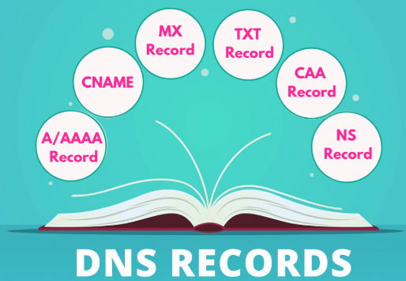

**How does DNS work?**

Here’s an overview of the DNS process:

1. ***User Request***: You enter a domain name (e.g., `www.google.com`) into your browser.
2. ***DNS Query***: Your browser sends a request to a DNS resolver (typically provided by your ISP (Internet Service Provider)) to find the IP address associated with that domain.
3. ***DNS resolver:***The resolver checks its cache. If the IP address is found, it returns it to your browser. If not, it queries other DNS servers.
4. ***Root Name Server***: If necessary, the resolver asks for a root name server. This server points to a top-level domain (TLD) server (e.g., `.com`).
5. ***TLD Name Server***: The TLD (Top Level Domain) server directs the query to the authoritative name server for the domain.  
   ***examples:*** *.com, .org, .net, .in* etc.
6. ***Authoritative Name Server:*** This server holds the actual DNS records and provides the IP address for the requested domain.
7. ***Response***: The DNS resolver returns the IP address to your browser, which loads the website.

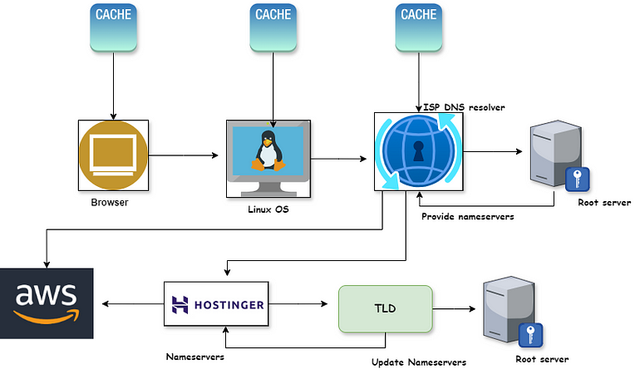

**Example:**

Here, we have taken a ***Facebook.com*** overview:

1.***User Request***: You type `facebook.com` in your browser, which needs the server’s IP address to connect to the website.

2. ***DNS****Query*: The browser asks the local DNS server for the IP address of `***facebook.com***`.

3. ***Checking DNS cache***: The local DNS server first checks if it knows the IP address. If not, it starts looking for it.

4. ***Contacting Root Server***: The local DNS server may ask the root name server where to find information about `***.com***` domains.

5. ***Finding the `****.com****` server***: The root server directs the local DNS server to the `***.com***` TLD (Top Level Domain) server, which knows where to find `***facebook.com***`.

6. ***Getting Facebook’s IP***: The local DNS server then asks the authoritative name server for `facebook.com` and gets the IP address.

7. ***Connecting to Facebook***: With the IP address in hand, the browser connects to Facebook’s server, and the website loads.

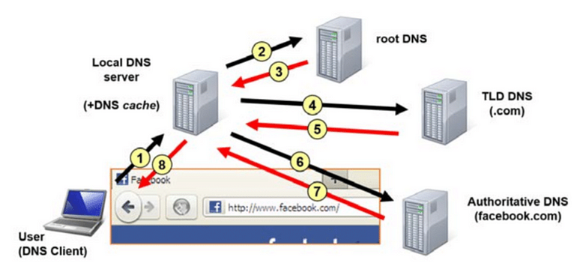

**Conclusion**

DNS is a critical component of the internet, bridging the gap between human-friendly domain names and the numerical IP addresses used by computers. By translating domain names into IP addresses, DNS allows us to browse the web, send emails, and use online services effortlessly. Understanding how DNS works helps us appreciate its role in ensuring smooth and reliable internet access.